West Hull Ladies
RRC

June Newsletter

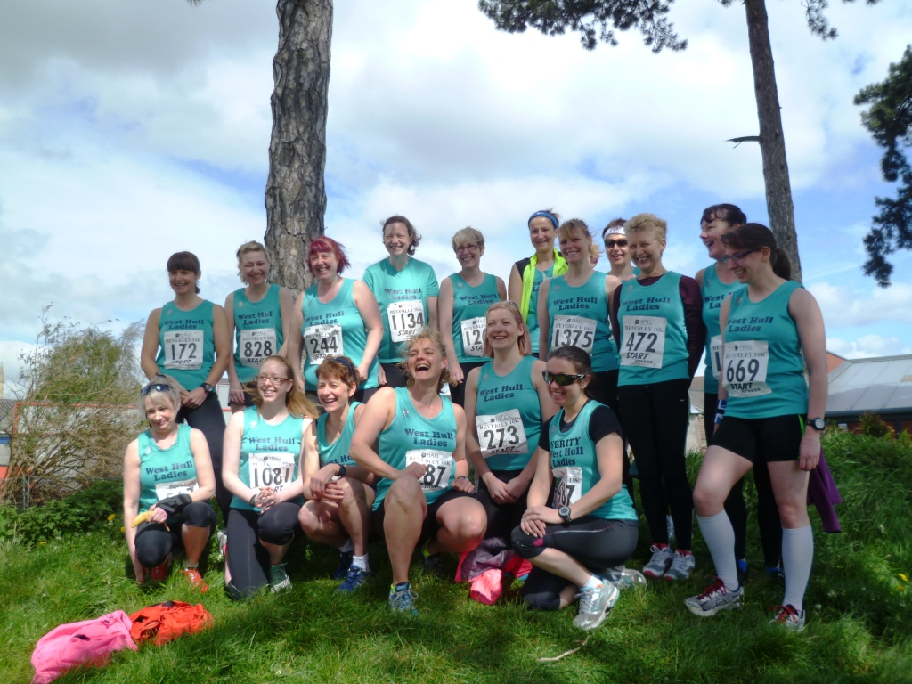

West Hull Ladies
Well Done to all those who ran Beverley 10k and Jane Tomlinson ‘10k’

WEST HULL LADIES RRC
COMMITTEE MEETING

Committee Meeting 3rd June 2013

Minutes

Present Rachael, Verity, Zoe, Debs, Maria, Debbie, Amanda, Sandra, Jill

- Apologies were received from Annette, Lisa, Ann
- Minutes of the previous meeting were approved
- Matters arising from previous minutes -
a) Sandra updated that she was still waiting to hear from Gary Sainty.
b) Rachael and Debbie updated that they had a meeting on Wednesday re the clubs rent.
d) Photos on skydrive – and passing on of numbers – Jill to send out email.
e) Mob run had taken place
f) Sandra said best times for training at Costello – Friday 8pm-9pm and weekends 1pm -3pm. To put out email asking if anyone interested
- Spoke about the proposed Hull Marathon. Club would be happy to support when more details of the route etc known. ACTION Jill to find out when next meeting of HAN is so we can have more members attend if possible
- Debbie updated that we had 44 full members – 2 second club members and 2 social members..
- Rachael spoke of ideas she had about organising a BBQ - still in the planning stage. She will speak to Valerie to sort out.
- Amanda reported that training was going well with high numbers of Ladies turning out. Concern was expressed at lack of buddies coming forward for a Friday night. Agreed that even if no buddy allocated any new member attending would be taken under the wing of one of the ladies on the night. Discussion about further training in relation to technique that Amanda would put on. Next date for this was the 14th June. Also said would try and arrange an evening when we could as a group do Pilates as this helps injury prevention. Amanda would also liaise with Jamie from Bodyfixed to see if he would come one evening and give knowledge on common injuries and injury prevention. ACTION – AMANDA TO CONTACT JAMIE.
- Date of next meeting 1st July. No meeting in August due to holidays.

Coaching Session: ‘Six of the Best’
Led by Amanda
Friday 14th June, 6:15pm Club

This session will concentrate on six key aspects of running style (running tall, shoulders, elbows, cadence/foot strike, core stability/hips, breathing).

Your running will be video’d for you to down load and view your own running style.

The session will also involve a warm up, dynamic stretches, drill work, exercises, speed work and static stretches.

For anyone racing at the weekend this can also be a light session.

Cheers,
Amanda

P.S. If the weather is horrible, I will postpone this session as it involves short periods of inactivity.

Beverley 10k

Ruth

The Background
When the entries opened for the Beverley 10k my racing buddy Sharron was nursing an injury and unsure how quickly she would recover, and I hate racing without Sharron, so we didn't enter. The Wednesday before the race Amanda asked Sharron if she and I wanted Kate and Suzanne's places as they were unable to run. Buoyed up by totally unrealistic optimism and ignoring the fact that we had run 6 miles only once in the previous 6 months we said we'd do it.

The Aims
My aims were very simple 1) to finish 2) to finish before they ran out of bananas and 3) to get a tee shirt (I like the Beverly 10k tee- shirts)
All aims achieved with the slight proviso that the tee - shirt is vaguely reminiscent of a Leeds United shirt, but as all Hull City fans currently like Leeds United I'll let that one go :)

The Actuality
Sharron and I found it a hard slog, but I found it got easier after 3 miles, while I think Sharron found it easier after 4. In fact we were so bad we walked up the hills!! We were the tail-enders - less than a dozen people finished after us, but the nice thing about the club is that everybody is very encouraging and it's ok to be very steady (aka slow). We decided to play to our strengths (definitely not running, then) and settled for being friendly, encouraging other runners, thanking people who were encouraging us, accepting sweeties from strange men, making people laugh: Carol took our photo as we were running down the Westwood (she must have waited ages for us) and asked whether we were enjoying it. In perfect unison Sharron and I said 'no', causing the bystanders to laugh, so one of them said would we do it again next year?. Again in perfect unison we said 'no' leading to much merriment.

The Salutory Reminder not to over-do it.
As we reached the bottom of the Westwood and were running through the streets towards Saturday Market we saw a man in running gear on the floor. It looked as if he had passed out and several people were around him, one of them with a mobile phone presumably calling the emergency services. Hopefully he is fine now.

The Surreal Bit
I noticed on the photos from the Hull Daily Mail (via the club web-site) that there was a man at the front of the start line looking very incongruous wearing 'normal' clothes and smoking a cigarette . After the first mile or so we caught up with him - he'd started walking, taken his jacket off and lit another cigarette!!! I engaged him in conversation (it's something I do, I can't help it) and he said he hadn't run for 20 years or so and he was expecting a car along very shortly with champagne............and very shortly afterwards a rather sporty-type car arrived (even though the road was still closed) and was directed onto the grass by the marshal. The mysterious man followed it. Didn't see him again so presumably (unlikely as it may sound) the lure of champagne was stronger than the lure of running 6 miles. I'm intrigued by him so If anybody knows how to access his name from his entry number - 1001 - I'll google him and see what turns up :)
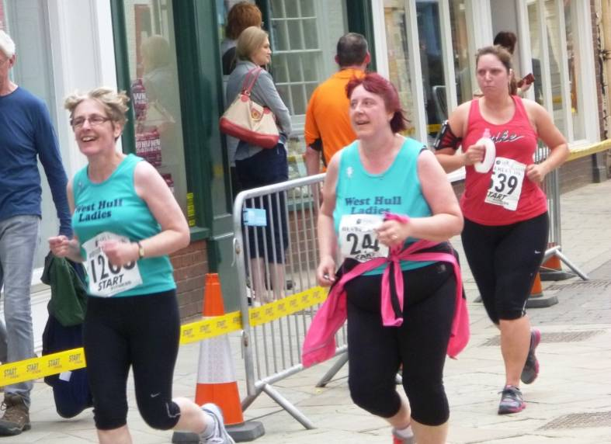
The Conclusions
It helps if you have trained, but if you haven't just take it really, really steady and enjoy the race. Sharron and I have entered the Jane Tomlinson race, so we are hoping for improvement.

Sharron

After being asked last minute if Ruth and I wanted to take Kate and Suzanne's numbers for the Beverley 10k we thought, "yeah, let's give it a go". So, we gathered excitedly before the run for a group photograph, which was bizarre as it started off with one person taking a photo, then another, then another, then the Hull Daily Mail, wow, I have never been 'papped' so much in my life!!!!
Now to the run, taking our usual spot at the back (we find we fit in that position quite nicely) we started off. Well, 10 minutes in, I was thinking “Why.....Wwwwwhhhhhhyyyyyy am I doing this????.....the hills....the wind......arhhhhh” I really struggled the first half of the run, my overall fitness obviously just wasn’t quite there. Ruth, I believe, was tiring also BUT we were pleased with our little selves after managing the first half of the run. The second half we both seemed to get a second wind. Ruth before me though, I was still complaining to her (sorry Ruth!) for another half a mile before my legs seemed to settle down, we even overtook a few other runners....yes you DID read that right!!! And the man offering out Jelly Babies toward the end: I could have hugged and kissed him FOREVER, he was a life saver!!!!
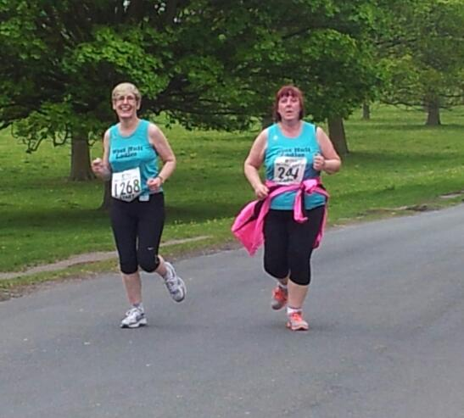
With the finish line in view, we dug deep, found some speed from somewhere and with the encouraging shouts from Ruth of “Come on, we can do this, we can finish in style”.....we did (for us). Was impressed with the fact we managed not to collapse in a heap in front of everyone cheering us in!
I've got to say the support was fabulous, there was a LOT of cheering from a LOT of people.
All in all, I'm very pleased I was able to run the Beverley 10k in the end and very proud of both Ruth and I, and indeed, all who took part.
Jill

I enjoyed Beverley last year when I did it for the first time (great tee shirt by the way), and I have done the Hull JT 10k for the past three years, so entered them both and then found that they were within a week of each other L. As well as this we are in the middle of the champagne league which runs every other Tuesday (eek). Anyway I thought that I would just have to get on with it and take it easy in between events so that I did not run my legs out!

I like the Beverley 10k, even though the route is hilly. It’s well organised and the atmosphere is great. It was lovely to meet up with everyone at Beverley Leisure Centre and after photos and watching a bit of the fun run, we went to the start. I began running with Jermaine, Verity and Sara, but we all spread out as the race progressed. It was really quite windy, which was good (because it keeps you cooler) and bad (because it seemed like a head wind all of the time!). Great support from Carol, Suzanne, Jo T, Kate and the girls on the way round (Thanks, it really does help). Generally I felt quite strong and really enjoyed the run back into Beverley, because there are loads of people to cheer us on.

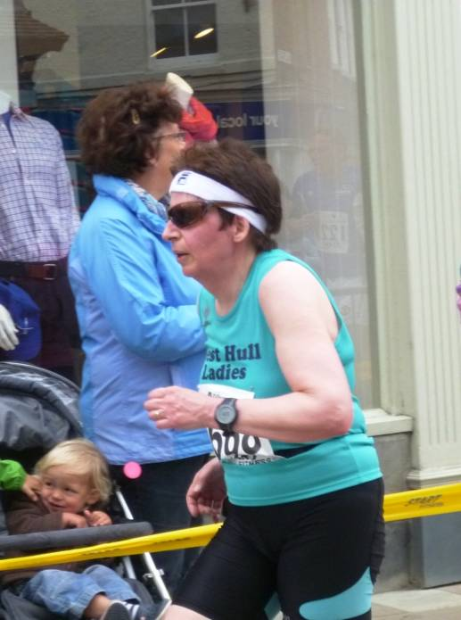
What was good about the race?...Apart from the above, I did a PB around 52 and a half minutes, got a nice tee shirt, saw Amanda winning her age category prize (nice one Amanda!) and had a good time with all the 20+ club members who were also running. What was not so good? I looked like an escapee from a kung fu film in the photos and...About three hours afterwards I got an awful headache (which I’ve had before after running events) felt really dreadful and was really sick (Yuk!)…Why did this happen?…well quite honestly I thought it was probably my own fault as I did not eat quickly enough after I had run, because I had stayed to watch the presentations etc. I ought to know better, because this has happened to me before, but not quite so badly. So although I was really pleased with my run on the one hand, I also got a warning from my body that I need to make sure that I recovered properly after an event.

Anna

My first ever 10k. I think that I signed up for this in the panic of places going so fast. Perfect- no time to think about it too much and change my mind!
I nervously joined the recce the week before, and am so glad that I did. Thank you to Verity for setting it up, and to the others for gathering up along the way. It was so helpful to do a trial run. I do like to know a route beforehand, and I felt much more confident about managing the distance.

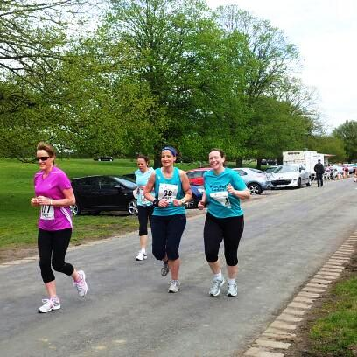
On the day it was much cooler than the recce had been- thank goodness, and I wasn’t nervous at all. It was such a nice part of the day meeting everyone first and getting ready together.

Loved the first mile- it was fun and there were plenty of people around. The second mile was dreadful with that hill! Also- the fact that you could see others running back across the other side of the field and back into Beverley was really off putting- it looked so far!
Turning that first corner towards Walkington though things felt much better. I had to stop at the second water station to have a little drink- am not yet able to throw away the cup/ bottle onto the ground- was brought up not to throw rubbish and I just cant do it!!

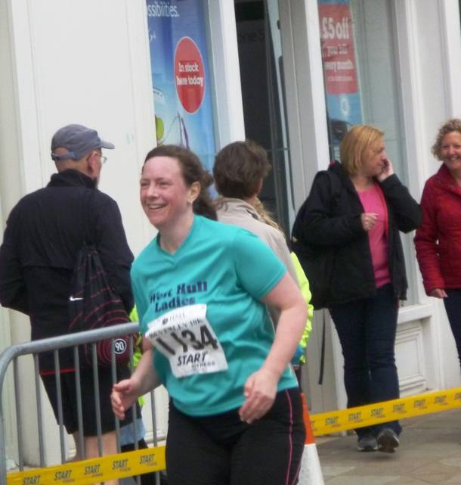
The run down the Westwood and into Beverley was great- really comfortable. And it was wonderful when WHL cheered on- what a difference- cheered me up and made me run a bit faster.

Big thanks to Jane who made sure that I just kept going. Every time I complained she popped a jelly bean my way! And she put up with a sort of runners tourettes that I seem to have developed- sneaky little swear words under my breath! Sorry Jane!!

It was a great day out- I can see why it is popular and I would definitely do it again next year.

And it was lovely to have a day out with my super club who I am so grateful to for giving me the confidence to things like this.

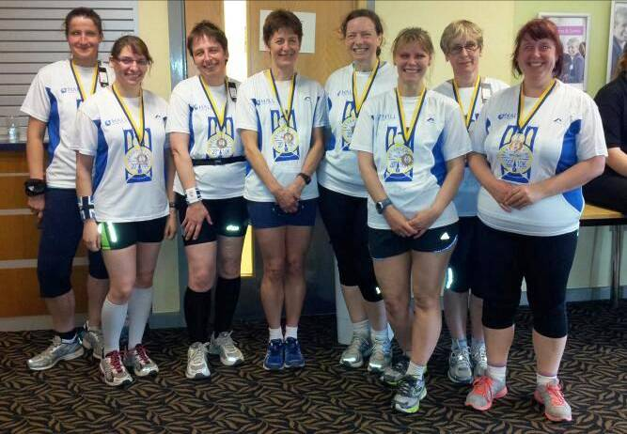

Jane Tomlinson Hull ‘10k’

Jill

So a week later at the Hull JT ‘10k’, I had my patent ‘Verity Pick’ inspired recovery kit: namely a packet of crisps, a chocolate bar and a bottle of milk…very ‘healthy’, but it makes some sense if you think about it, as this includes, fats, protein, salts, liquid and sugars, and however daft it seems…it really does work. So although I felt tired after the Hull event, I felt relatively well otherwise.

However the Hull event was a bit of a disappointment. Apart from the fact that they seemed to have less toilets this year which meant that we decided to run back to Princes Quay for our last ‘mental wee(!!)’, they then announced that they were having to change the course route due to a jammed bridge near the marina. The bottom line here was that our 10k became a 9k!!!! This of course, as you will all realise, is a problem in respect of our club 10k competition. LAnyway the up-shot of this was that I did the race in just under 46 and a half minutes…probably the one and only time that I will ever go sub 50mins in a ‘10k’race (lol!). I decided that the best policy for the race was to enjoy it and wave at all the cameras, and make sure that I had a good recovery…and that’s what I did. Good runs once again from the contingent of WHL runners and thanks to Jermaine and Sandra for their support at various places in the race, and we all got yet another good tee shirt! And now I’ve had to enter the Humber Bridge 10k to try and get another 10k time!

Sharron

Well, Ruth and I didn’t know which way this run would go, (a good run??? A bad run????) after finding the Beverley 10k quite hard the previous Sunday but, we turned up and placed ourselves (as usual) toward the back of the runners and waited for the countdown to begin.
We set off full of high spirits, taking it easy (as we do), though we still had our moan of “why on earth are we doing this”, etc etc BUT we carried on, took in water, overtook runners. We saw Sandra and Jermaine twice, it was nice to get a cheer from them, spurring us on. My husband and brother and children kept popping up at various places....scaring the life out of us....er....LOUDLY cheering us on, so that was nice!
Ruth and I kept checking we were both ok, we were. We were surprisingly ok. We began to find, around the 5/6k mark that we were actually having a good run, we’d not stopped and we felt good. We remained positive; reminding each other of the fact that we hadn't needed to walk and that we were still over taking other runners. Near New Theatre we caught sight of Carol which was nice, I must say she looked very comfortable indeed. That glimpse of Carol helped me lot because I really dislike that turn left toward New Theatre, when I really, really, DESPARATELY want to turn right and join in with all those running toward the finish!
Anyway, after that, Ruth and I kicked in at the ‘400 metres to go’ sign and with encouragement from each other had a real good sprint to the finish which brought us in just under the hour mark.
I know this run only turned out to be around 9k but we were so thrilled with our time. Initially, when they announced it was 1k short, Ruth and I turned to each other, smiled and inwardly cheered. However, as we were running in, knowing the finish line was creeping up and even though we were trying hard with our sprint, I personally was wishing now, knowing how I was feeling with how the run was panning out, that if it was the full 10k, I think.....I THINK......this would have been a good time, maybe even a PB for me and possibly even Ruth....but....there we go....things happen which are beyond our control!!!
So, all in all, a good run. We both feel very positive after this 10k and eager (is the word ‘eager’ going to come back and bite me on the bum I wonder???!!!) to have a go upping our weekly mileage. Obviously, all the while, taking up our rightful place (chatting) at the back of the group!!! Ha! We are not THAT eager......
Ruth

To Sharron and me races are like buses; none for ages and then 2 come along together. After our poor showing in The Beverley 10k and the knowledge that our training consisted of running 10k twice in the last 6 months (both involving some walking and, in one case, sitting down) we gamely turned up for the JT race. I was convinced it would be better than the Beverley 10k, Sharron less so. When we found out the race was only 9k we both heaved a huge sigh of relief (feel free to contradict me Sharron) and set off steadily – for us there is no other way.

I decided I would use a man who looked a bit like a fridge as our pacer – he was wearing a tee-shirt indicating he’d run the race in 2010 so he knew the ropes and he was running with quiet determination (or desperation) but he looked more like a guy in the gym who aims to lift the maximum number of weights possible without killing himself or doing himself an injury. Anyway I thought he’d do very nicely. We saw Jermaine and Sandra cheering us on – and blithely waved at them. As we were ambling on Viccy Dock we saw the really fast runners running the other way, we were impressed by them but not moved to emulate them. Let’s not pretend – we couldn’t emulate them.

After the first water station I lost the fridge so we had to manage without a pacer, but by that time we were finding our rhythm (yeah, right), and were steadily over-taking people. However some people who thought they could run and had set off too fast were using a combination of running a bit, then walking a bit which is REALLY irritating when you want to overtake them. Maybe we should introduce capital punishment for people who over-estimate how fast they can run. Highly unlikely Sharron and I will ever commit that crime! Rant over.

We saw Mandy, looking good in her first 10k, to think less than 4 months ago she was on the absolute beginners course!! Saw Sandra and Jermaine again and waved to them while they took our photo – who says we don’t take running seriously, then round onto the Marina where Sharron’s husband Nige and daughters Emily and Olivia were waiting to cheer us on (twice). That was really nice. Then at the junction of Lowgate and Silver Street we had a double cheer – one from Sharron’s brother who seemed to appear out of nowhere frightening me to death and one from a work colleague of mine. We started winding our way through the town and passed several people dressed as characters from Toy Story – disappointingly no-one was dressed as Stinky Pete - wonder why that was. Going through town Sharron saw Carol and I saw Jane - both in front of us obviously. Sara and her children were encouraging us just as we were approaching Queen’s Gardens, then Sharron’s lot were cheering us on near M&S, and we cantered in in just under an hour, just in front of Elvis (don’t ask). Well done us. We celebrated by spending the next 20 minutes looking for Nige and the girls because we’d not arranged anywhere to meet ☺

I achieved my aims of getting round and getting a tee-shirt. And it’s a technical tee-shirt this year – really good result. Bring on the next race, but like buses, it might be quite a while before it appears.

Five Reasons to Love Running

We know the common reasons for starting a running routine: fitness, weight loss, personal achievement. Here are the running4women team's five favourite reasons to love running.

Reason 1 to Love Running: Beat Stress
Modern life is stressful for us ladies - work, finances, parenting, relationships and body image worries can all pile up leaving us feeling frazzled and overstretched. Running is a great stress-reliever. Not only does it give us that much-needed "me time" but it physically helps by regulating hormones which keep us feeling balanced and able to cope with life's demands. So, next time you find yourself turning to an unhelpful coping strategy, go for a run instead (or at least plan your next run)!

Reason 2 To Love Running: Be Focused
Far from making you too tired to think, running actually sharpens your mental faculties, making you perform better in mental tests, verbal communication and memory recall. What a great bonus from your favourite fitness pastime!

Reason 3 To Love Running: Boost Your Mood
We've all heard of "runner's high" - it refers to the way running floods our systems with endorphins, making us feel super-happy and sometimes super-human! So, next time you're feeling down, stressed, sad, angry or wound up into a knot of tension… go for a run. Even a short jog will do the trick. Pair it with a playlist of uplifting tunes to really make the most of the natural high .

Reason 4 To Love Running: Sleep More Soundly
Insomnia is more common that you'd think, with more than half of us struggling to fall asleep or stay asleep at some point in our lives. This is usually due to stress or the inability to unwind and relax. Running can help beat insomnia. Running helps release a host of helpful hormones including endorphins, whilst helping minimise others such as cortisol (the stress hormone). Make sure you leave at least two hours between running and bedtime and you should find a regular run helps you drift off.

Reason 5 To Love Running: Live Longer
Eating well and staying active adds up to five years to our lifespans. And who wouldn't want to live longer when looking at an old age where you'll be fitter, healthier, more mobile and more independent than those who weren't active in their younger years? Add life to your years, and years to your life, by running. Definitely a top reason to love running!

Since lots of ladies are running in races, some for the first time, I thought I’d share this article from women's running on how to get over a ‘bad’ race.

Take control and you’ll find it easier to bounce back after a poor performance, explains coaching editor Phoebe Thomas

For many of us, running wouldn’t be running without racing. The goal and target of peaking for a key race is what motivates us to attack the miles in training. As a coach, I try to help runners to hit their peak on race day. Most of the time this results in a great performance, but sometimes life just isn’t on your side. And when that happens, the best training plan or advice in the world can’t stop external factors taking over. Whatever the reason for a bad race, the important thing is that you deal with it and move on. Sit down and think about what went wrong and why. Once you’ve identified the reason you failed to perform, you can learn from it. We all feel emotional as we cross a finish line, so wait for several days after a race – good or bad – to absorb and analyse what happened.

Accentuate the positive
If you have a bad race, start by determining why it was bad. Did you miss out on a new PB due to your own performance or did external factors ruin your race? If the factors were external – such as a much hotter day than usual, unexpectedly windy weather, or an over-crowded course – then understand that these factors were beyond your control and move on. You can still take something positive from the race. A sustained hard run is likely to have taken your fitness forwards massively, ensuring you’re in great shape for the next race. There are some factors, however, that you can prevent or scenarios that you can avoid. All you need to do is take control.

Heavy legs
I often hear people complain of heavy, tired legs during a race. Ask yourself if you started the race properly fuelled – and I don’t just mean a good breakfast. You should eat healthy carbs in the week leading up to every race, and particularly in the last 48 hours. Fail to do so and your muscles will struggle to maintain pace. Did you make the mistake of training hard right up to race day? Your last long run or hard session should take place ten days before you race. This ten-day taper leading up race day should feature less volume, smaller sessions and shorter runs to ensure you’re fresh when the gun goes off. A lack of shuteye in the days before your race might also leave you feeling heavy legged, so aim to get plenty of sleep in the week leading up to the race. A frantic working week can lead to stress, which results in a feeling of lethargy on race day. If possible, arrange your diary so you have a lighter week before a major race. You could even take a day off if you’re really gunning for a PB. Heavy legs and lethargy can also be down to your menstrual cycle. Research suggests that you’re likely to run at your peak mid cycle or two thirds into your cycle, but everyone’s different. If you can, work out how your body responds throughout the month and try to plan your races around this.

Poor pacing
Maybe your pacing was off or you just couldn’t maintain your target pace for the full race. Did you practise race pace in training? Was your target pace realistic? Miracles won’t happen on race day so it’s essential that you run at race pace in training. Did you start a fraction slower and build the pace gradually or begin too fast then struggle to hang on? If you push the pace from the start, the lactate spike that occurs when you zoom off unrealistically fast is impossible to recover from and results in a weak performance later in the race. World-class runners always aim for a negative split (a faster second half to the race), and if it’s good enough for Paula Radcliffe, it’s good enough for you. Many of us have to deal with negative racing gremlins and little voices, saying things like, ‘It’s too hard, I can’t keep going’. This negative thinking can prevent you from pushing the effort in the final stages of a race. You need to find mental strategies or distraction techniques to create a positive mind-set. Rehearse these strategies in hard training sessions then use them on race day.

The course
The course will make a huge difference to your performance, so do your homework. People often say to me afterwards, ‘It was more hilly than I expected’. Nothing about the course should be a surprise on race day. Study the route or read other people’s race reviews before signing up. Remember that successful racing is about controlling the things you can control and not stressing about the things you can’t. You can control how much rest you get the week before you race. You can ensure you’ve rehearsed your race nutrition strategy. You can plan your race pace and splits. Take control and you’re more likely to reap the rewards of all your hard work in training and hit your race goal.

Racing and Running Events
Fancy something different? For worldwide marathons click here
Date/Time | Event | Fee | Entry forms | Online entry
June 2013
9th/11:00 | The Humber Bridge 10K | £11 UKA /£13 | Entry form | Online entry
30th/09:00 | Humber Bridge Half Marathon | £20 | Entry form | Online entry
July 2013
12th/19:30 | Walkington 10K | £11 UKA/£13 | Information - online entry only | Online entry
14th/09:30 | Jane Tomlinson's Leeds 10K | £25.20 or click here for season ticket | Entry form to follow | Online entry
Aug 2013
4th/09:30 | Jane Tomlinson's York 10K | £25.20 or click here for season ticket | Entry form to follow | Online entry
Sept 2013
8th / 10:00 | Major Stone Half Marathon | £15 | Entry form | Online entry(+£1@UKforms.net)
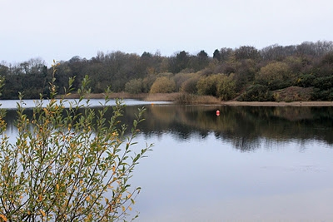
Try a Tri?

Olympic Distance - 13th July
Ripon – have a look at the promo video

Children’s Triathlon – 8th June
Rother Valley - 150 metres swim / 4km cycle / 1.2k run
Check out the website here – this is a whole weekend of triathlon, including a ladies only sprint event

Keep checking the website for new races and updates: www.westhullladies.org.uk/races.htm Verity, Racing Officer

NOTE: Club Vests must be worn at any races you enter
under the West Hull Ladies running club name.

Clubwear
PRICES:
Vest | £16.00 | All items are ordered on request and must be paid for at time of ordering. To place an order please print the kit order form and hand completed forms to Maria.
T- shirt | £16.50
Hoodie | £14.00
Jacket | £32
Beanie Hat | £6.50



New Club Jacket available in three sizes: small, extra small, and junior (large fitting). If you would like to purchase one please send a cheque for £32 to Debbie Watson, Treasurer, and state on the back of your cheque your name and that the cheque is for a jacket.

Jill

Running Library

You can borrow any of these books – they are upstairs near the toilets at the end of the corridor
Book List:
- The Runner's Diet (Runners World), Madelyn H. Fernstrom
- Paula My Story So Far, Paula Radcliffe
- The Runner's Handbook, Bob Glover
- The Competitive Runner's Handbook, Bob Glover & Shelly Lynn Glover
- Marathon Running For Mortals, John Bingham

- Lore of Running,

Running Magazines: These are available to borrow by emailing the club website.
Mark your email for the attention of Jo.

West Hull Ladies Road Running Club
Kit Order Form

FORENAME ___________________________________

SURNAME ___________________________________

ORDER - tick what you require, with size Price

- VEST SIZE _____________ £16.00
- T SHIRT SIZE _____________ £16.50
- JACKET SIZE _____________ £32
- HOODIE SIZE _____________ £14
- BEANIE HAT £6.50

DATE Ordered _______________

AMOUNT PAID _______________

Please make Cheque payable to ‘West Hull Ladies’
Write your name and order on the back.

Sign on receipt of goods _________________________________

DATE _______________

Please print this form, complete and hand to me with your cheque/cash.
Thanks.
Maria
Kit Officer

